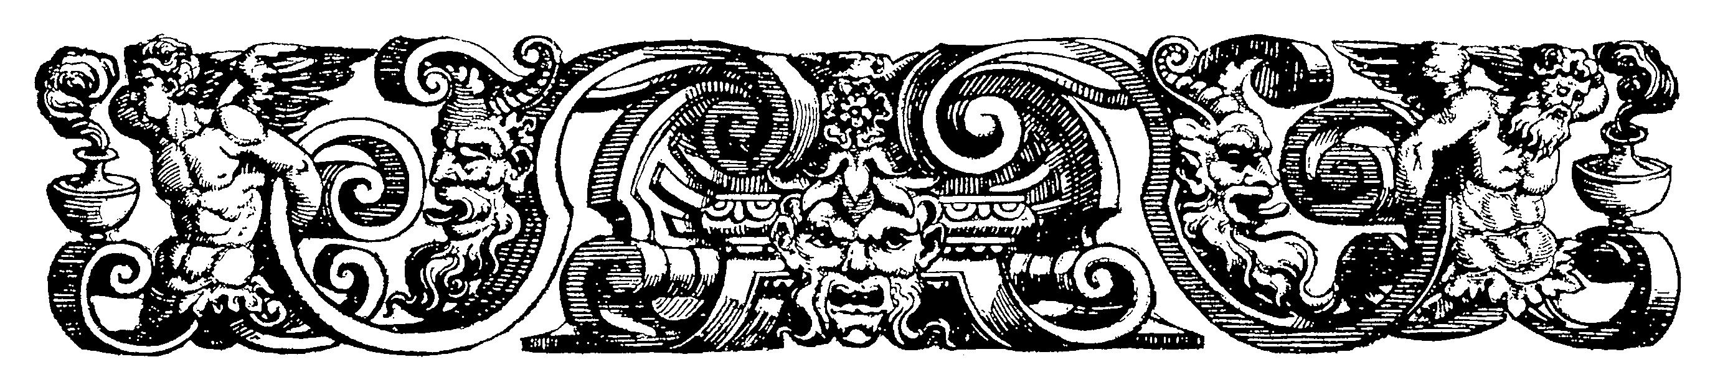
ARTH 480 ART HISTORY fall 2010
IDEAS & ART

T/R 3:30-4:45Rutledge 127
Dr. Laura Rinaldi Dufresne
102 McLaurin x 2662 dufresnel@winthrop.edu
Office hours M/W 3:30-4:30pm & by appt.

Required Readings : See attached List & as well as any art history survey textbook

Course Objectives: This course is organized thematically, not chronologically, in order to explore one monument of western European art in its cultural context. We do so by studying another great work from a different discipline created during the same time period. For example when we examine Marcel Duchamp’s The Large Glass as a piece of dada anti-art, we will also read Freud’s Civilization and its Discontents. The two pieces selected for each theme are not related (except for the case of the City of Ladies) but are connected by theme. By looking at them in tandem we hope to experience the variety of factors at play in each work, thereby gaining a truer and deeper understanding of each.

Course Requirements: 100 points total

3 essays (20 each) 60
2 Reading Presentations & Leading Discussion (10 each) 20
Reading Summaries (10 out of 12) 10
Attendance Preparation (notes)& Participation 10
Grading Scale: 94-100% = A; 90-93 = A-; 87-89 = B+; 84-86 = B; 80-83 = B-; 77-79 = C+; 74-76 = C; 70-73 = C-; 67-69 = D+; 64-66 = D; 60-63 = D-; 59 or less = F
GNED: ARTH 480 fulfills GNED requirements for Historical Perspective and Humanities and the Arts. Goal 1.1 Read, write and speak standard English is met through writing assignments and essay exam questions, Goal 3.2 Analyze and use a variety of information gathering techniques is met through the research paper assignment, Goal 4. 1 Analyze diverse world cultures, societies, languages, historical periods, and artistic expressions and Goal 6.1 To understand aesthetic values, the creative process, and the interconnectedness of the literary, visual, and performing arts throughout the history of civilization are met through reading, lecture, research and exams on course description content.
Expected Learning Outcomes include recognition, understanding and appreciation for the driving concepts of an age or culture with regard to its major works of art as well as literature, philosophy, essays or poetry. Writing skills with regard to themed essays (Community, Rebel, Ideal & Real) will be developed and or improved through satisfactory written Standard English and higher level compositional and critical thinking skills.
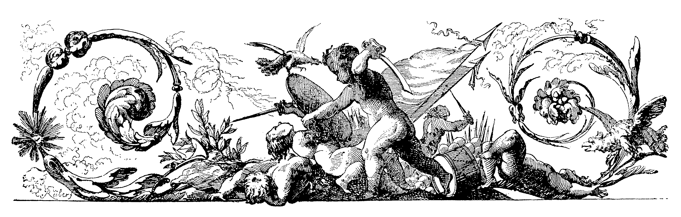
IDEAS & ART - THEMES:

- THE COMMUNITY
a.)The Lindesfarne Gospels centuries & Bede’s Life of St. Cuthbert ( 7-8th)
b.)The City of Ladies & Christine de Pizan’s The City of Ladies (c. 1410)
c.) Jacob Lawrence’s Harriet Tubman & W.P.A. Arts Program (1930’s)

- THE REBEL
a.)C.D. Friedrich’s Cross on the Mountains & Bronte’s & Wordsworth (18th-19th)
b.)M. Duchamp’s The Large Glass & Freud’s Civiliz. & It’s Discontents (20th)
c.)Frieda Kahlo’s Self Portraits & Isabel Allende’s Eva Luna (20th)

- THE IDEAL
a.)The Doryphorous by Polykleitos & Plato’s Timeaus (5thc. bce)
b.)Pope Julius II as Art Patron & Leon Battista Alberti’s Della Pittura (c.1500)
c.) Mies van der Rohe’s Seagram Bldg. & Clive Bell’s Art (20th)

- REALISM
a.)Trajan’s Column & The Meditations of Marcus Aurelius (2nd)
b.) Caravaggio’s Death of the Virgin & Descartes’ Discourse on Method (16-17th)
c.) Berta Morisot’s Harbor at Lorient & Baudelaire’s Painter of Modern Life 19th

Classroom Rules:
- Take notes! On everything –lectures, readings, films…
- Participation is part of your grade, so speak up!
- more than 3 absences results in a lowering of your grade
- sleeping in class &/or excessive tardiness will result in a lowering of your grade
- no cell phones, text-messaging, ipods, working on homework etc. in class
- no late work accepted without doctor’s excuse, etc.

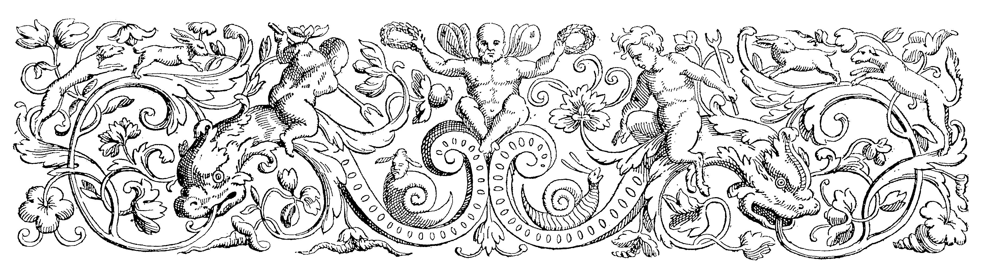

Ideas & Art Calendar (subject to change)

8/24 Introduction to course

THE COMMUNITY

Unit One The Lindisfarne Gospels (8th)
26 & 31 Bede’s Life of St. Cuthbert discussion

Unit Two The City of Ladies (15th) by the City of Ladies Master
9/2 & 9/7
9/9 Christine de Pizan’s The City of Ladies discussion

Unit Three Jacob Lawrence’s Harriet Tubman Series (20th)
9/14 & 9/16 W.P.A. Art Program Documents discussion
(Summary of THE COMMUNITY)
9/21 Writing Consults

THE REBEL

Unit Four Casper David Friedrich’s Cross in the Mountains (19th)
9/23 & 28 Essay One Due 9/23
William Wordsorth Tincturn Abbey & poetry of Brönte Sisters (Charlotte, Emily & Anne BOOK) discussion

Unit Five Marcel Duchamp’s The Large Glass (20th)
9/30 & 10/5 Sigmund Freud’s Civilization & its Discontents discussion

Unit Six Frieda Kahlo’s Self Portraits
10/7 & 10/12 Isabel Allende’s Eva Luna discussion
(Summary of THE REBEL)
10/14 Writing Consults

THE IDEAL

Unit Seven The Doryphorous by Polykleitos
10/19 & 21 Essay Two Due 10/21
Discussion of Plato

Unit Eight Pope Julius II as Patron of Art (High Italian Renaissance)
10/ 26 & 28 Leon Batista Alberti’s Della Pittura discussion

Unit Nine Mies van der Rohe The Seagram Building NYC (20th)
11/2 & 11/4 Clive Bell’s Art discussion
(Summary of THE IDEAL)
11/9 writing consults

THE REAL

Unit Ten Trajan’s Column (2nd century)
11/11 &11/16 Essay Three Due 11/11
The Meditations of Marcus Aurelius discussion

Unit Eleven Caravaggio’s Death of the Virgin (c. 1600)
11/18 & 11/23 Descartes Discourse on Method discussion

Thanksgiving HOLIDAY

Unit Twelve Berta Morisot’s Harbor at Lorient 19th
11/30 & 12/2 Baudelaire’s “The painter of Modern Life discussion
(summary of REALISM)

ESSAY 4 DUE FINAL’s PERIOD – 11:30 am Friday December10th
Laura Dufresne Ideas and Art
Readings

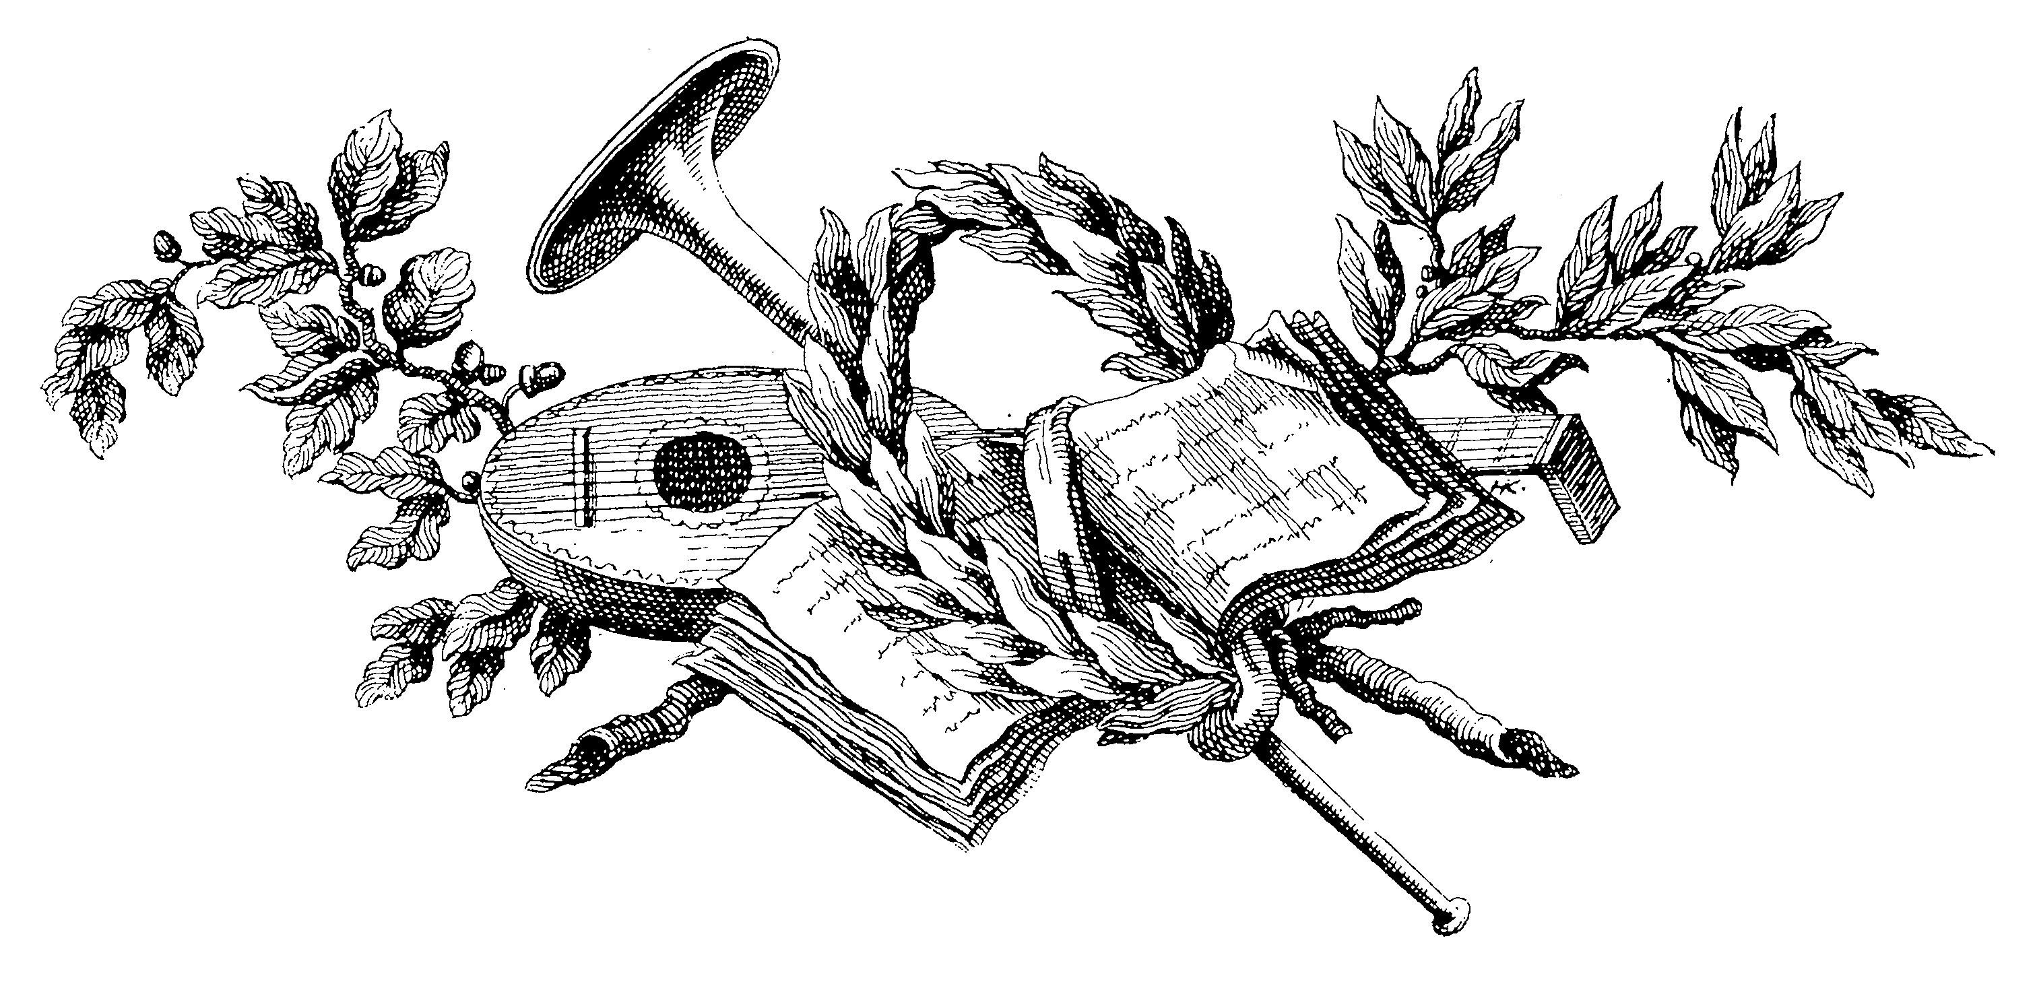
1. Alberti, Leon Battista. On Painting (15th century)

2. Allende, Isabel, Eva Luna (Bantum Books)

3. Aurelius, Marcus Meditations http://classics.mit.edu/Antoninus/meditations.html

4. Baudelaire, Charles. The Painter of Modern Life – essay Xerox

5. Bede’s (the Venerable) Life of St. Cuthbert
http://www.fordham.edu/halsall/basis/bede-cuthbert.html

6. Bell, Clive, Art. (c. 1900) http://www.gutenberg.org/etext/16917

7. Christine de Pizan, The Book of the City of Ladies, (15thc) translator, Earl Jeffrey Richards.

- William Wordsworth Tincturn Abbey http://www.rc.umd.edu/rchs/reader/tabbey.html
& poetry on nature and/or rebellion by by Currier, Ellis, & Acton Bell – the Brontë Sisters Poetry (19th) BOOK or http://www.gutenberg.org/etext/1019

9. Descartes Discourse on Method- (16^{th? 17th?}) http://www.gutenberg.org/etext/59

10. Freud, Sigmund. Civilization & Its Discontents, Forward by Peter Gay
Norton & Co. NY

11.Plato’s Timeaus http://classics.mit.edu/Plato/timaeus.html

12. WPA – N8838 .M32 Author McKinzie, Richard D Title The New Deal for artists [by] Richard D. McKinzie Imprint [Princeton] Princeton University Press [1973]
GENERAL COLLECTION Call # N8838 .N4 Title The New Deal art projects; an anthology of memoirs. Edited by Francis V. O'Connor Imprint Washington, Smithsonian Institution, 1972
(lists art from every state http://www.wpamurals.com/)
(posters by WPA http://memory.loc.gov/ammem/wpaposters/about.html)

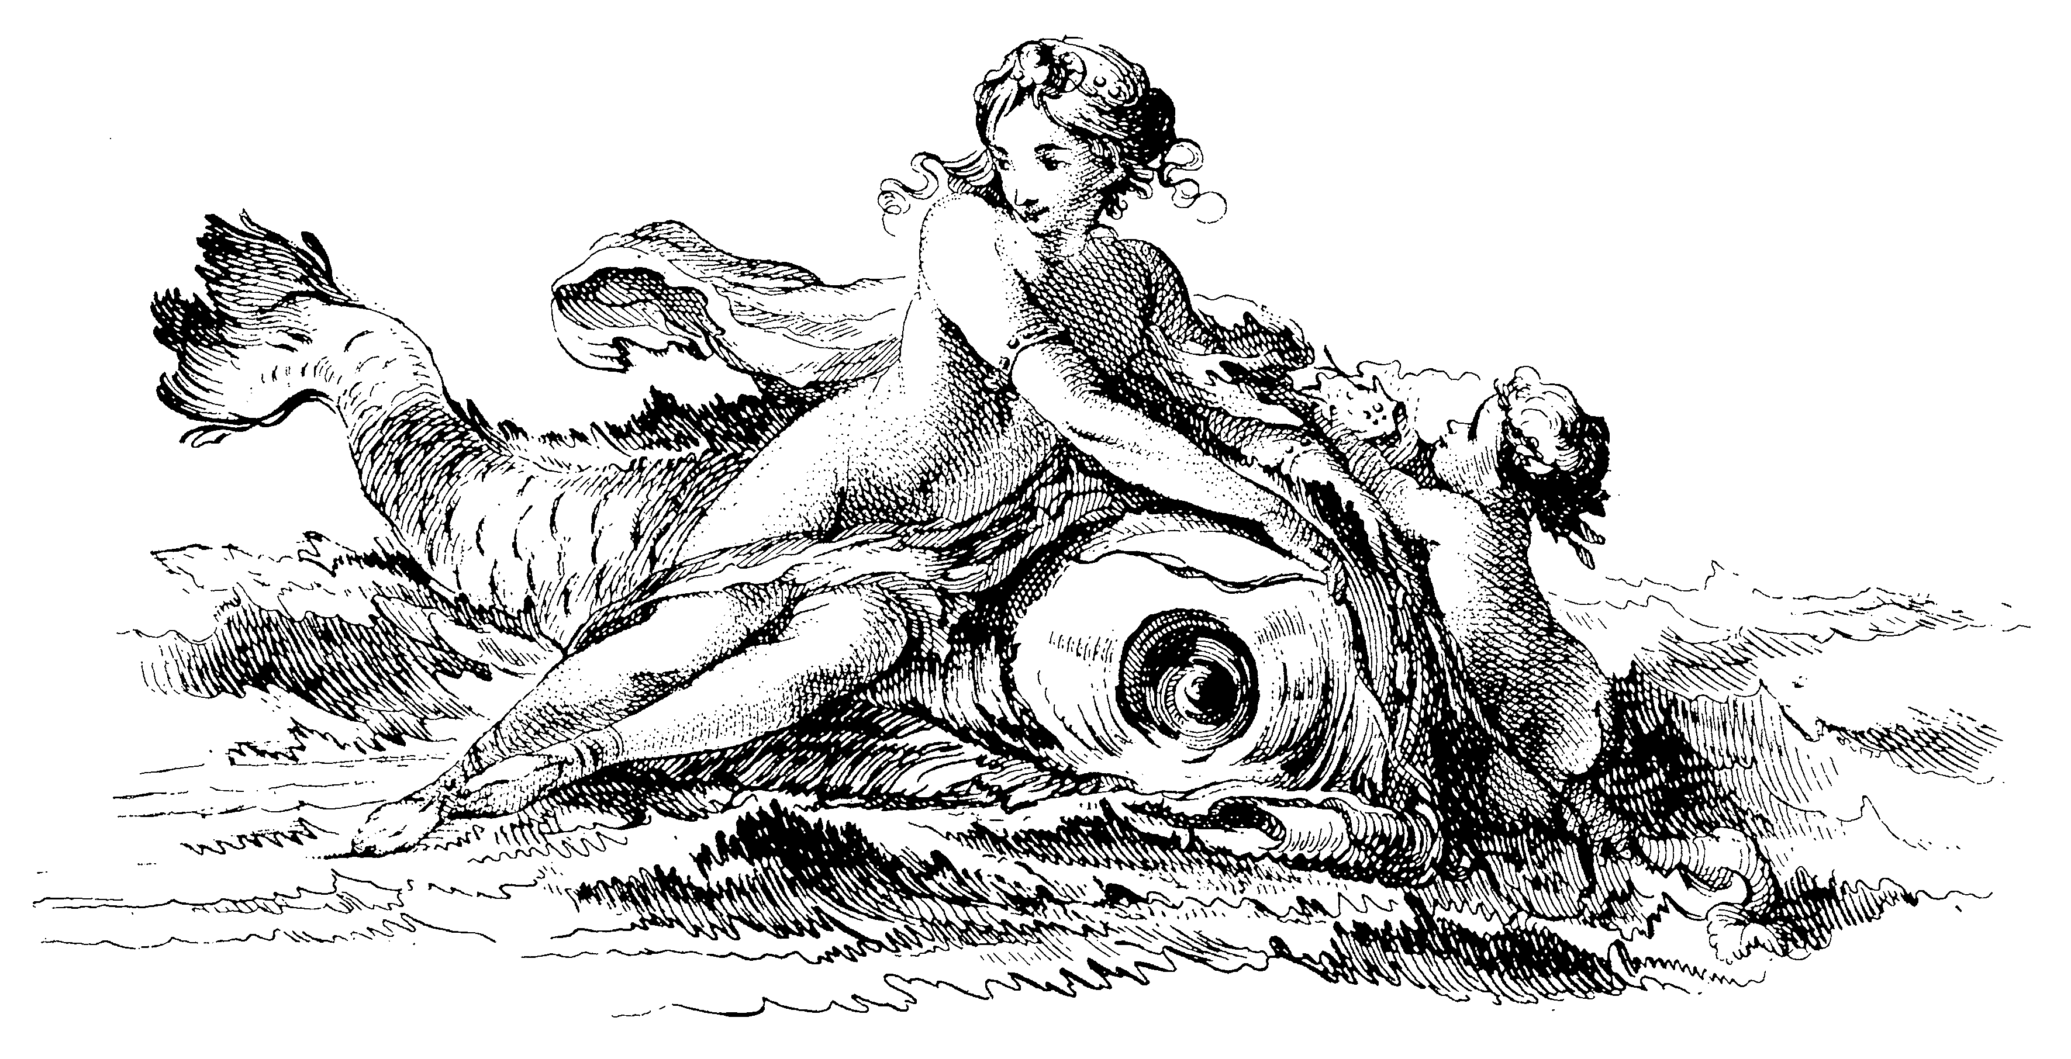
ASSIGNMENTS 100 points
- ESSAYS 60 POINTS (20 EACH)
There are four Themes of three units each. At the end of each theme there will be an essay assignment given (due dates see calendar).
You are only required to write three out of the four possible essays. There are also writing consultation days to help you refine and rewrite your essays.

- PRESENTATION & DISCUSSION LEADING 20 POINTS (10 EACH)
- Everyone will be required to Lead the discussion on two units of readings. You will need to turn in a typed list of discussion questions for the class after the discussion. (8 points (4 points each.))
- You will also give a short report on the author and the reception of the written work for the same two units. You will be asked to turn in 1-2 page typed report after the discussion . (12 points (6 points each)).

- READING SUMMARIES 10 POINTS
Everyone is required to turn in a reading summary on discussion day on a 4x5 index card, neatly printed , on the day those readings are discussed. You should use them to aid in the discussion of the readings that day. ( 12 reading discussion days, you are only required to turn in 10 reading summaries)

- PARTICIPATION & ATTENDANCE 10 points
These points are given for general discussion of readings and participation on the days when you are NOT the discussion leader. Points are also taken off on your 4th and all subsequent unexcused absences.
How to Review an Article -.

- Read it at least two times.
- State: Author, Title, and Date of Publication.
- Thesis Statement.
Why was this written? Purpose? Main Point?
State Thesis in One or Two sentences only!
- How is the article structured? Thematic or Chronological subheadings? Etc.
- What is the methodology of the writer? Historical? Marxist? Formal or aesthetic?
Museum Curator? Artist? Collector?
- What are the major points of each section?
Does the author cite many supportive facts or examples, Or focus on just a few? Why?
Include only the best supportive points in your review – not all.
- What is the tone of the article/book? Persuasive? Angry? Scholarly? Detached? Personal? Humorous?
- Who is the intended audience? Students? Professor? Artists?
- What were your favorite parts of the article? Amazing facts, personal stories?
- Was the article successful in proving the thesis? What were the strengths and weaknesses, if any?
- Did you find the article useful? Why or why not?
- Summary: Consolidate your findings as expressed in #3 & 10.



- Keep in Mind -
- In general, the articles I assign are written for other scholars, not students. Therefore they will be difficult. You may critique the writing, but not for being too difficult.
- For any scholarly reading expect to read it twice before attempting to write a review. It will become much clearer the second time around.
- Take Notes during that second reading.
- Paraphrase as often as you can. Avoid long quotes.
- Regarding number 4 – cite all sources properly, even when paraphrasing.
- If presenting your review in class – do not read from a highlighted Xerox of the article! Have note cards or prepared presentation – well organized and ready to read (especially if you are nervous.)

